Practical 7
Aim
To download, install, and configure Windows Server 2025 in VMware Workstation Pro and enable Remote Desktop Protocol (RDP) for remote access.
Requirements
- Windows computer/laptop
- VMware Workstation Pro
- Internet connection
- Windows Server 2025 Evaluation ISO
- Minimum recommended resources for the lab VM:
  - 2 or more virtual CPU cores
  - 4 GB or more RAM
  - 60 GB or more virtual disk space
  - Network adapter enabled
Part A — Download Windows Server 2025 ISO
Step 1: Open Microsoft Evaluation Center
Open the official Microsoft Windows Server 2025 Evaluation Center page:
Microsoft Evaluation Center – Windows Server 2025
The page provides options including Download the ISO and Download the VHD. For this practical, we will use the ISO.
Step 2: Select Download the ISO
- On the Windows Server 2025 Evaluation Center page, select Download the ISO.
- Microsoft will display a registration form.
- Enter the required information.
- Submit the form to proceed to the download page.
Step 3: Select the ISO
On the download page, select:
English (United States) → ISO download → 64-bit edition
This corresponds to the option shown in your third screenshot. Microsoft currently lists the English (United States) Windows Server 2025 ISO as a 64-bit edition.
Step 4: Download the ISO
- Click the 64-bit edition ISO download option.
- Save the ISO file to your computer.
- Wait for the download to complete.
The downloaded ISO will be used as the installation media for the VMware virtual machine.
Note: This is an evaluation version. Microsoft states that the evaluation edition expires after 180 days. Microsoft also states that evaluation installations must be activated over the internet within the first 10 days to avoid automatic shutdown.
Part B — Create Windows Server 2025 Virtual Machine in VMware
Step 5: Open VMware Workstation Pro
- Start VMware Workstation Pro.

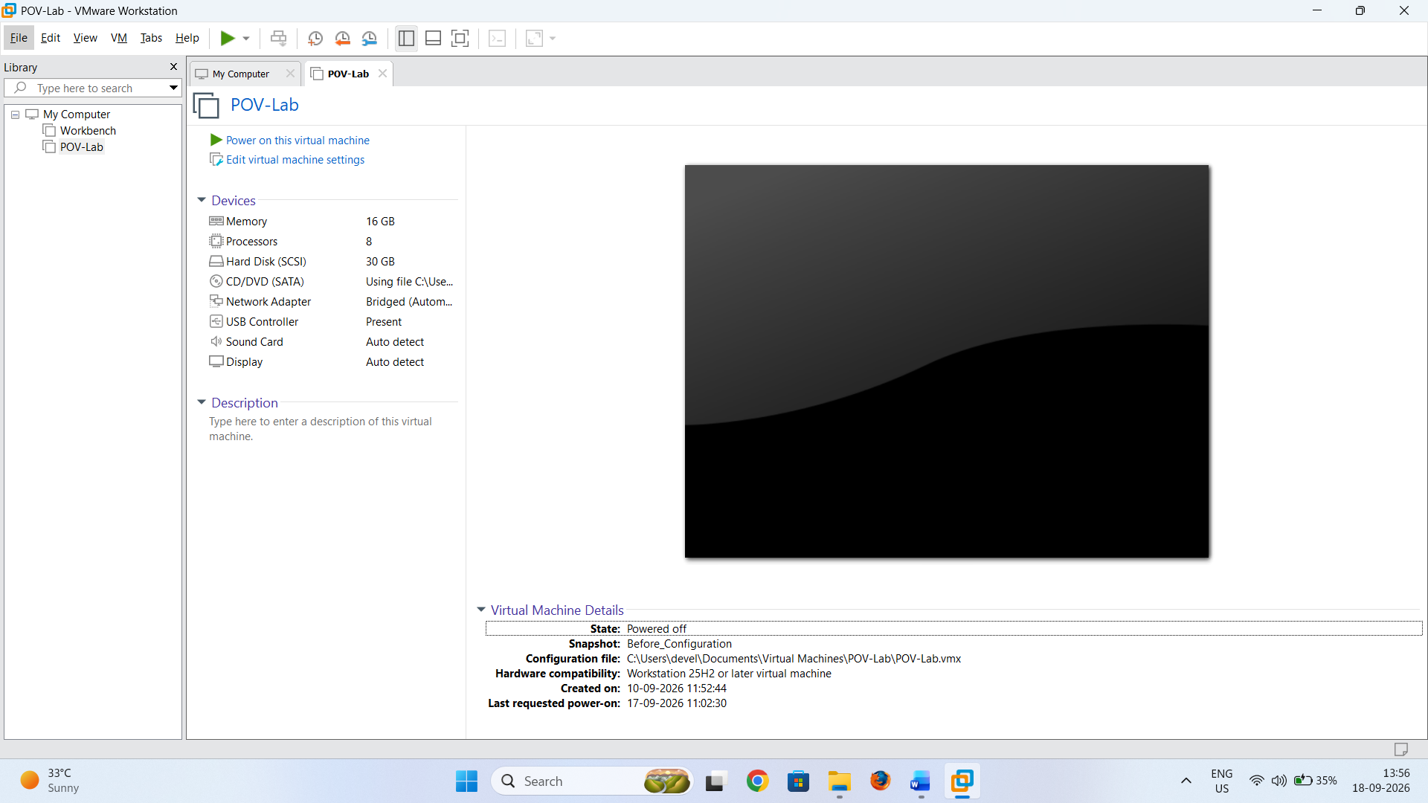
- Select Create a New Virtual Machine.

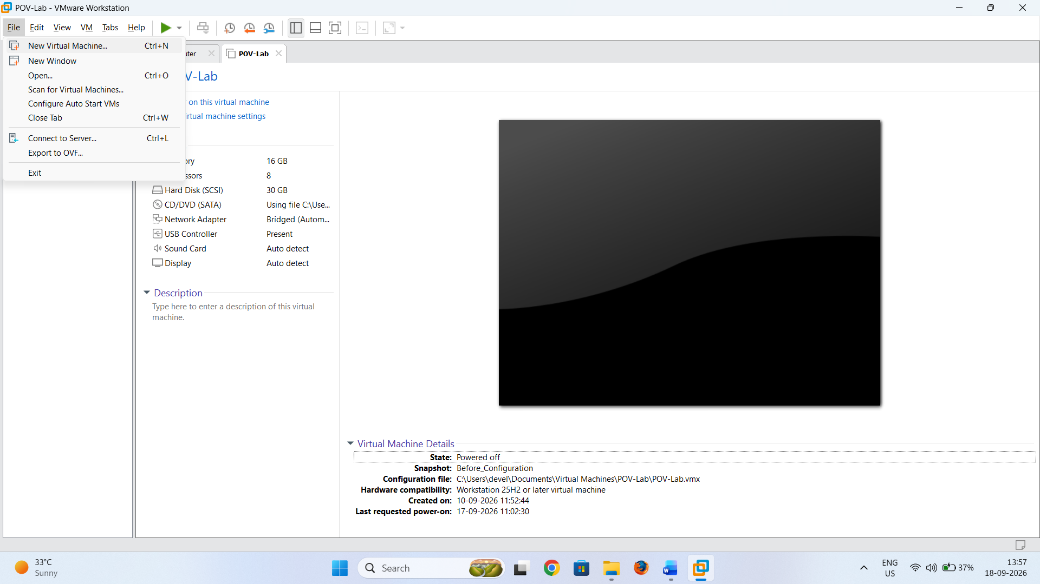
- Select Typical (recommended).
- Click Next.

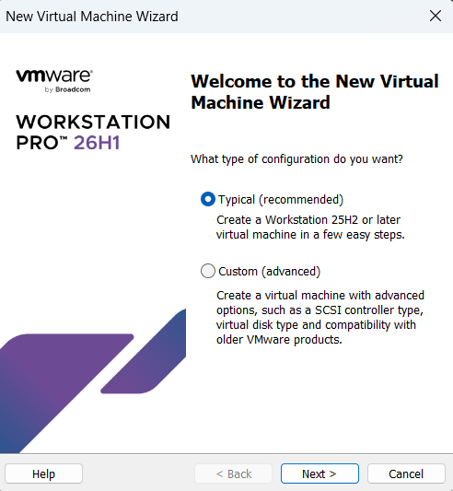
Step 6: Select How the Operating System Will Be Installed
In the New Virtual Machine Wizard, VMware will ask how you want to install the operating system.
Select:
I will install the operating system later.
This option is used because the Windows Server 2025 ISO will be attached to the virtual machine after the virtual machine has been created.
Click Next.
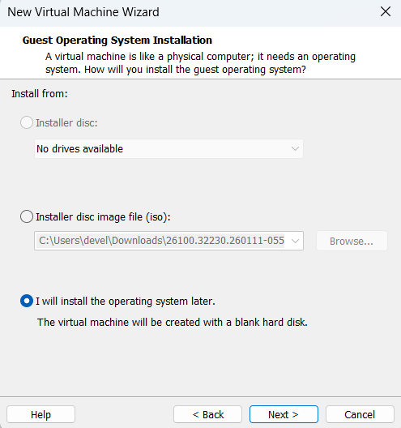

Step 7: Select the Guest Operating System
The Select a Guest Operating System window will appear.
Select:
- Guest operating system: Microsoft Windows
- Version: Windows Server 2025
Click Next.
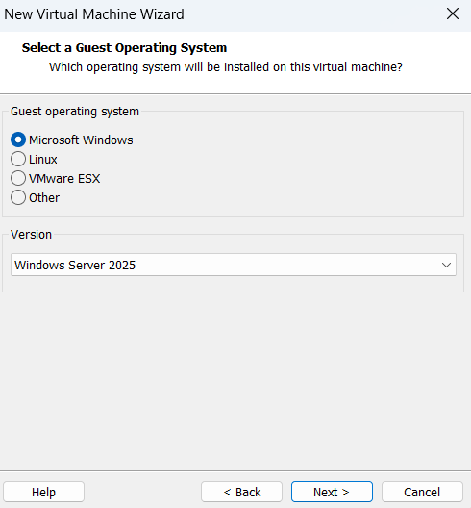
Step 8: Name the Virtual Machine
Enter a suitable virtual machine name, for example:
Windows Server 2025 RDP Lab
Select a suitable location where the virtual machine files will be stored.
Click Next.

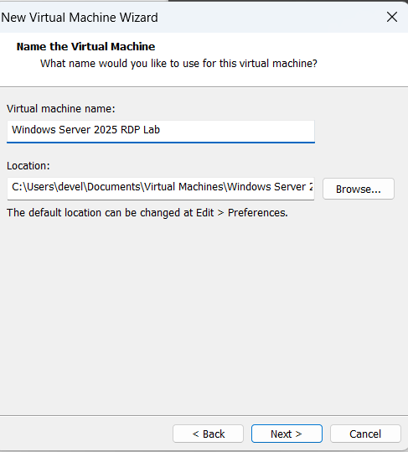
Step 9: Configure the Virtual Disk
Configure the virtual disk according to the laboratory requirements.
Recommended:
60 GB or more
Select:
- Store virtual disk as a single file.
Click Next.
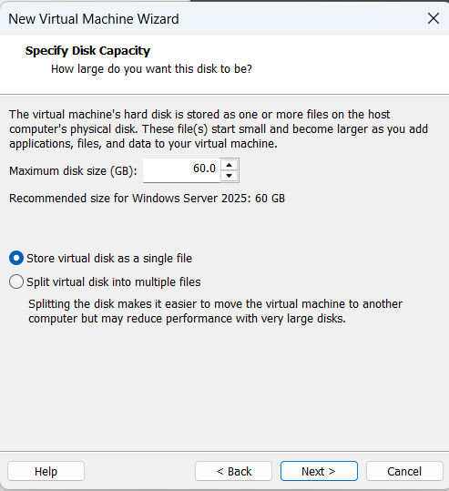
Step 10: Customize Hardware
Before completing the virtual machine creation, select:
Customize Hardware

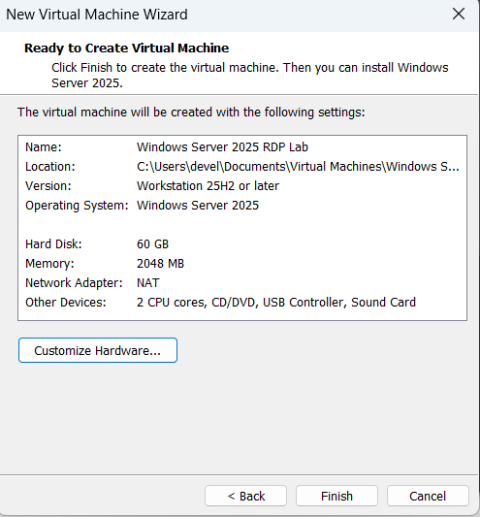
Suggested laboratory configuration:
Hardware | Suggested Value
Memory | 4 GB or more
Processor | 2 or more cores
Hard Disk | 60 GB or more
Network Adapter | NAT or Bridged
CD/DVD | Configure in the next step

Click Close after configuring the hardware.
Then click Finish.
The Windows Server virtual machine will now be created, but the operating system has not yet been installed.

Part C — Attach the Windows Server 2025 ISO
Step 11: Open Virtual Machine Settings
- Select the newly created Windows Server 2025 RDP Lab virtual machine.
- Make sure the virtual machine is powered off.
- Click:
Edit virtual machine settings
The Virtual Machine Settings window will open.

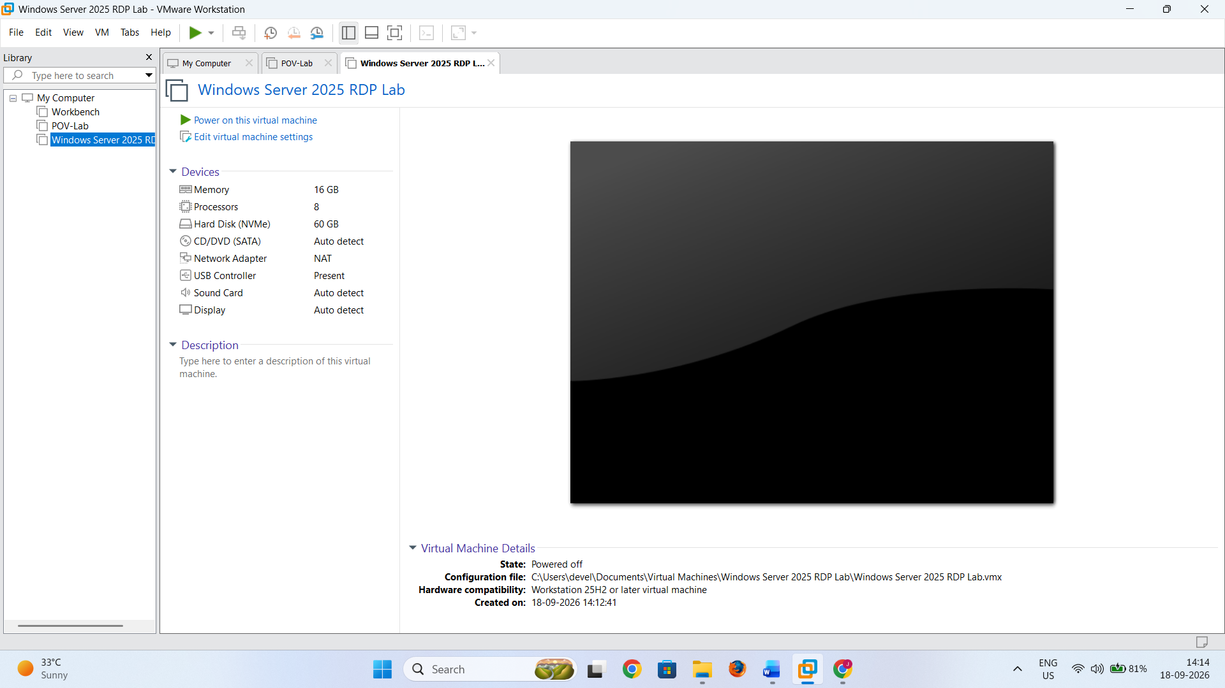
Step 12: Attach the Windows Server 2025 ISO
- Select CD/DVD (SATA) from the hardware list.
- Select:
Use ISO image file
- Click Browse.
- Locate the downloaded Windows Server 2025 Evaluation ISO on your computer.
- Select the ISO file.
- Make sure the option:
Connect at power on
is enabled.

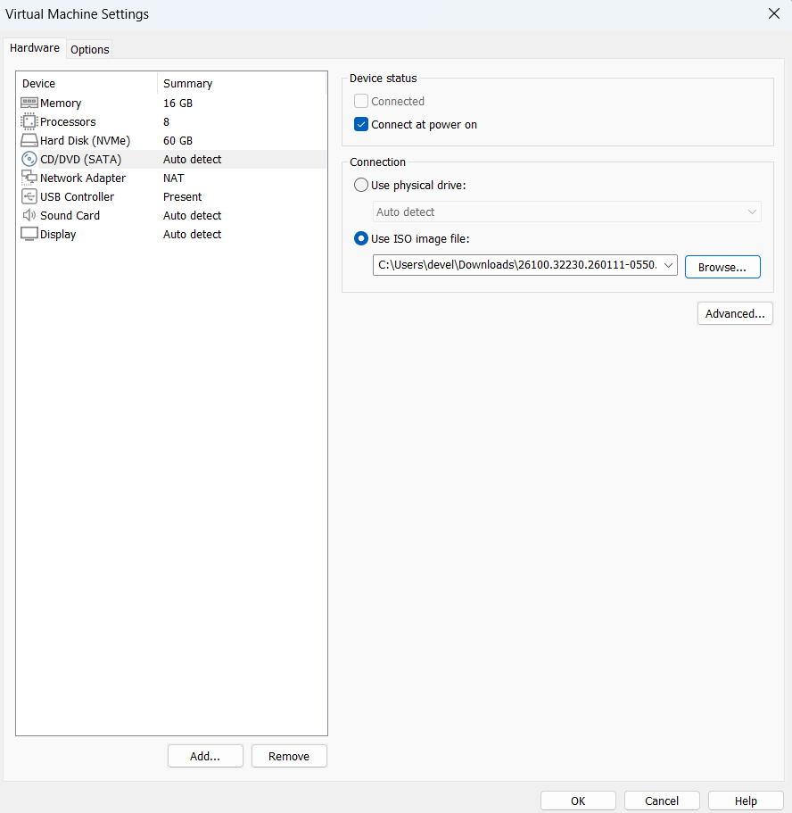
- Click OK.
The Windows Server 2025 ISO is now attached to the virtual CD/DVD drive.
Part D — Install Windows Server 2025
Step 13: Start the Virtual Machine
- Select the Windows Server 2025 RDP Lab virtual machine.
- Click Power on this virtual machine.
- The VM should boot from the attached Windows Server 2025 ISO.
Windows Setup should appear.

If the VM does not boot from the ISO, shut down the VM and verify that CD/DVD → Use ISO image file and Connect at power on are enabled.

Step 14: Start Windows Setup
When Windows Setup appears:
- Select the appropriate Language to install.
- Select the desired Time and currency format.
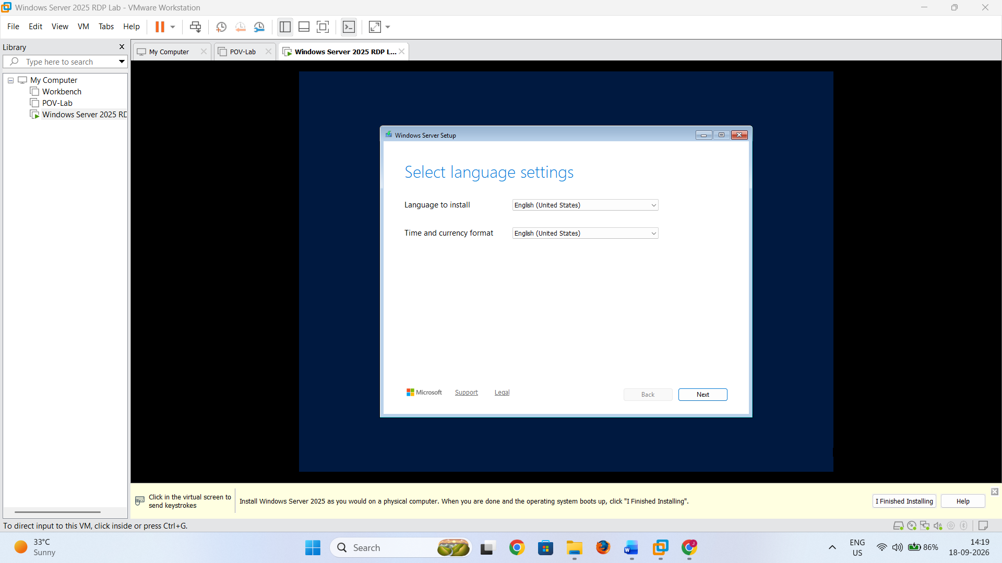
- Select the appropriate Keyboard or input method.

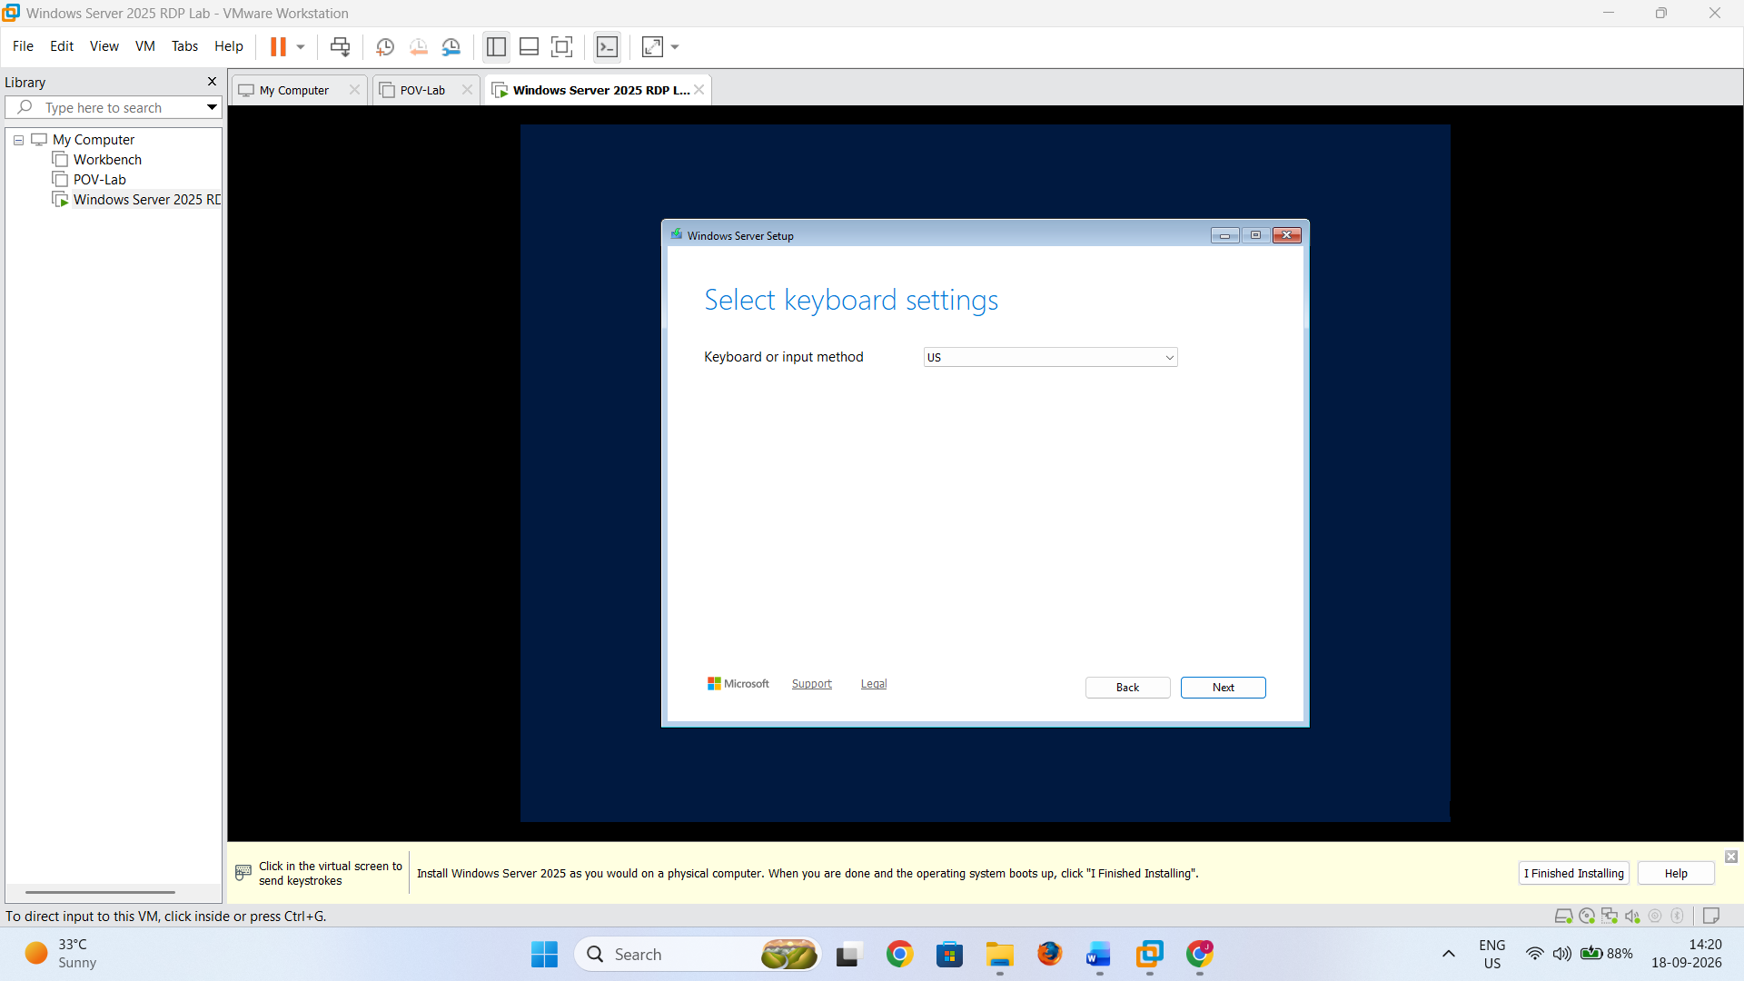
- Click Next.

- Choose Install Windows Server, check mark the agreement and click Next.

Step 15: Select the Windows Server Edition
Windows Server Setup will display the available editions.
For this practical, select:
Windows Server 2025 Standard Evaluation (Desktop Experience)
or the equivalent:
Windows Server 2025 Datacenter Evaluation (Desktop Experience)

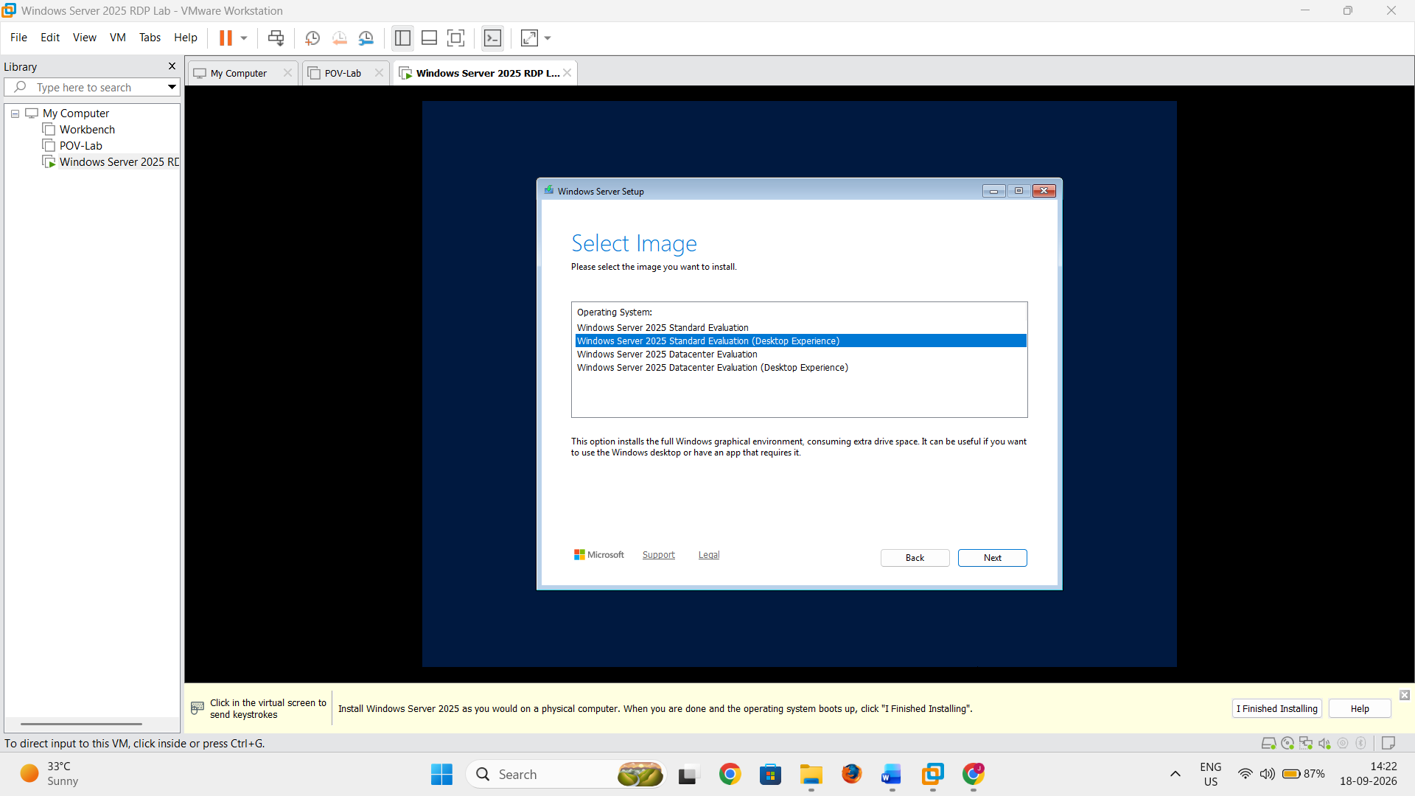
Click Next.

Step 16: Accept the License Terms
- Read the applicable license terms.
- Select:
I accept the license terms
- Click Next.

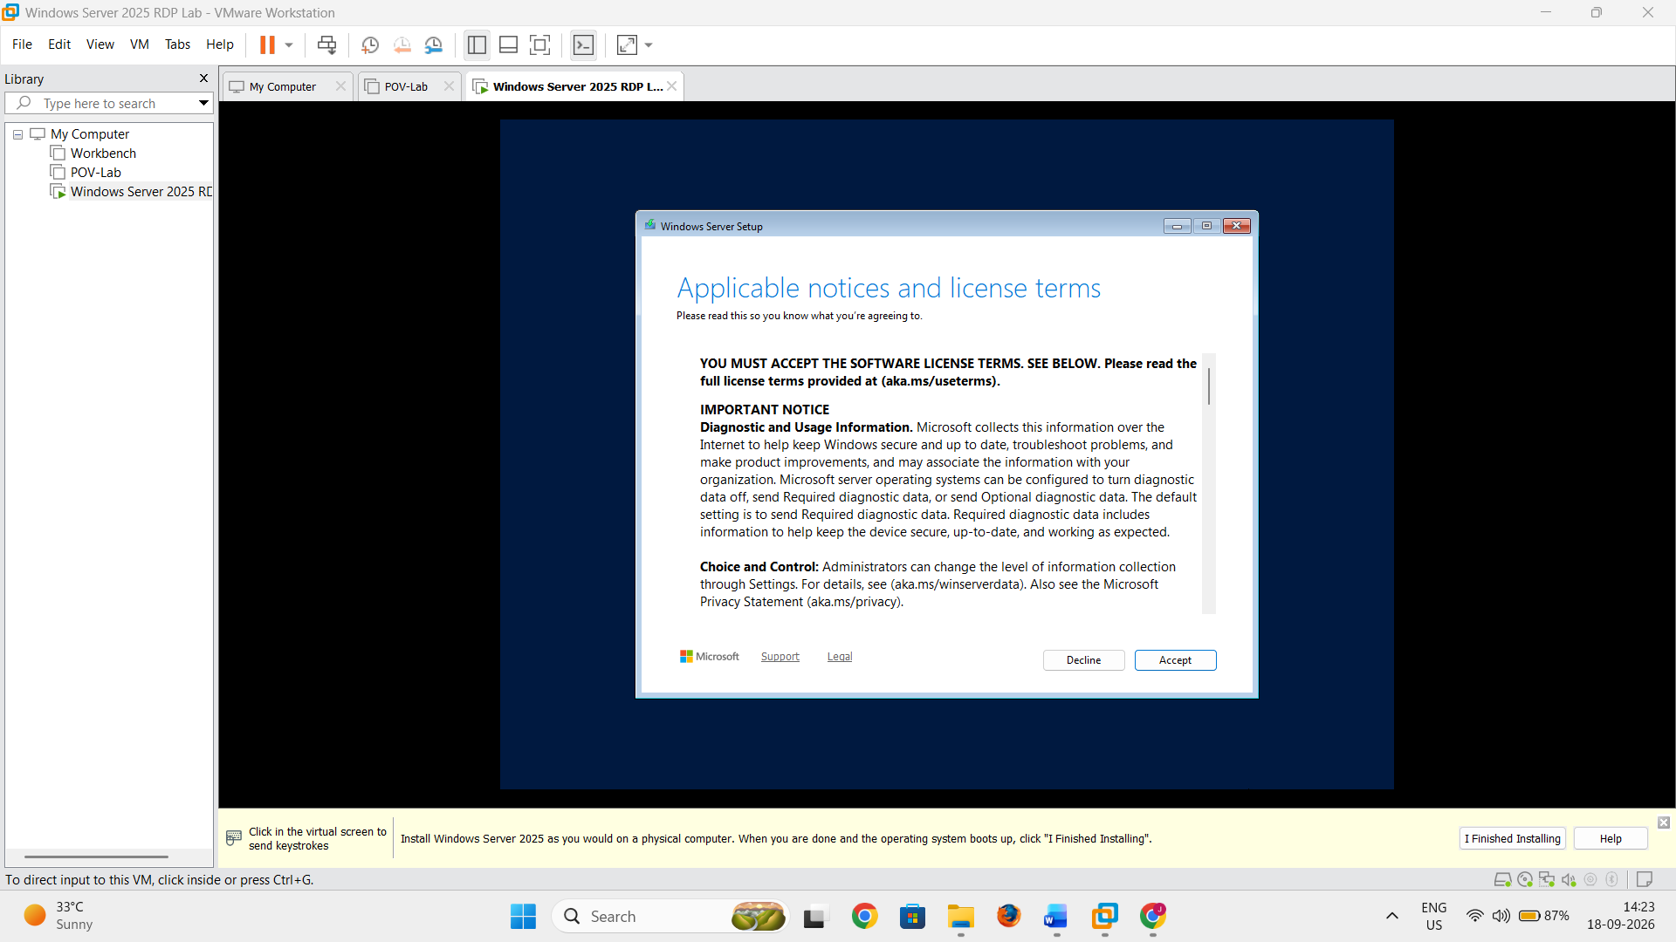

Step 17: Select the Virtual Disk
- Select the virtual disk created during the VMware virtual machine configuration.

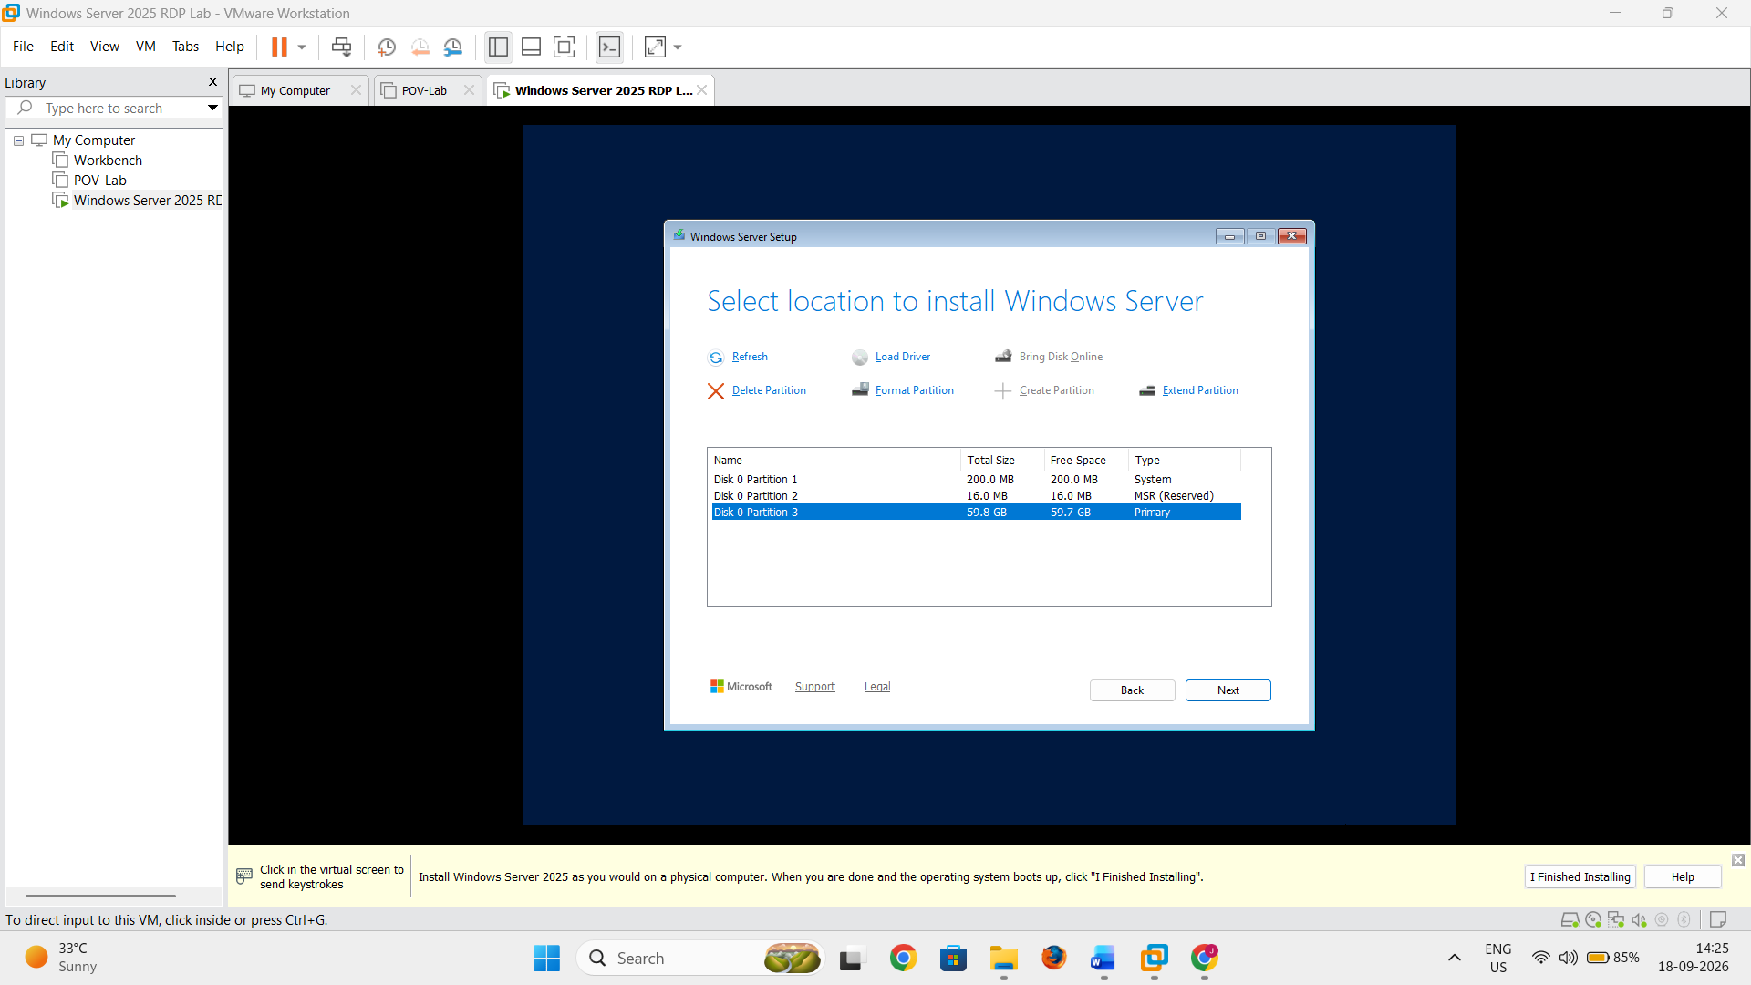
- Click Install.

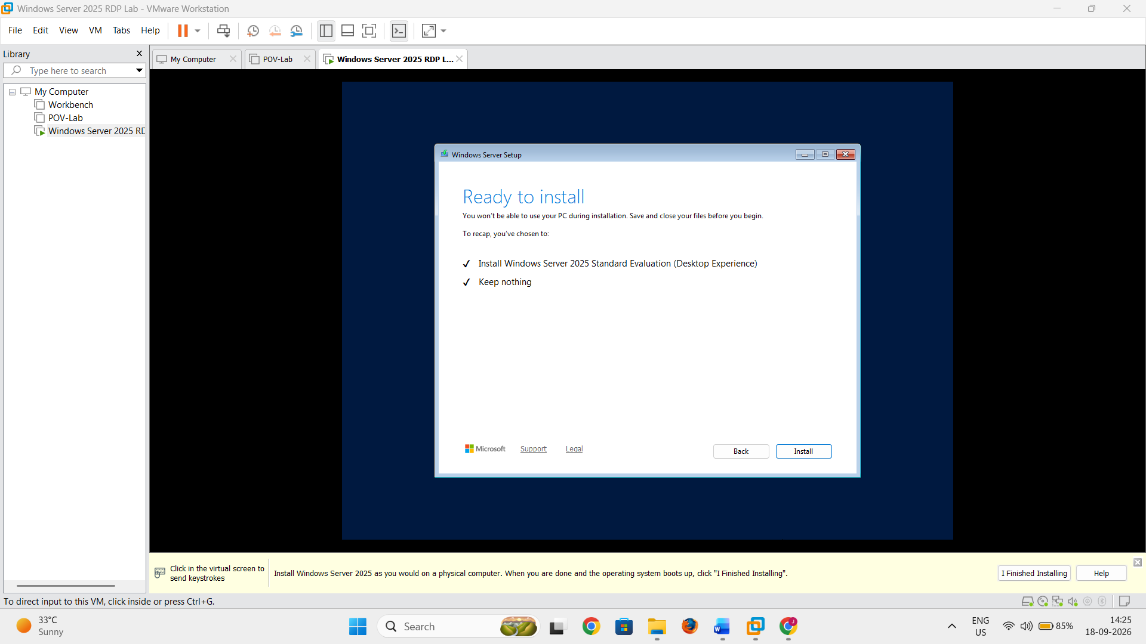
Windows Server Setup will begin installing the operating system.
The installation may take several minutes, and the virtual machine may restart several times.

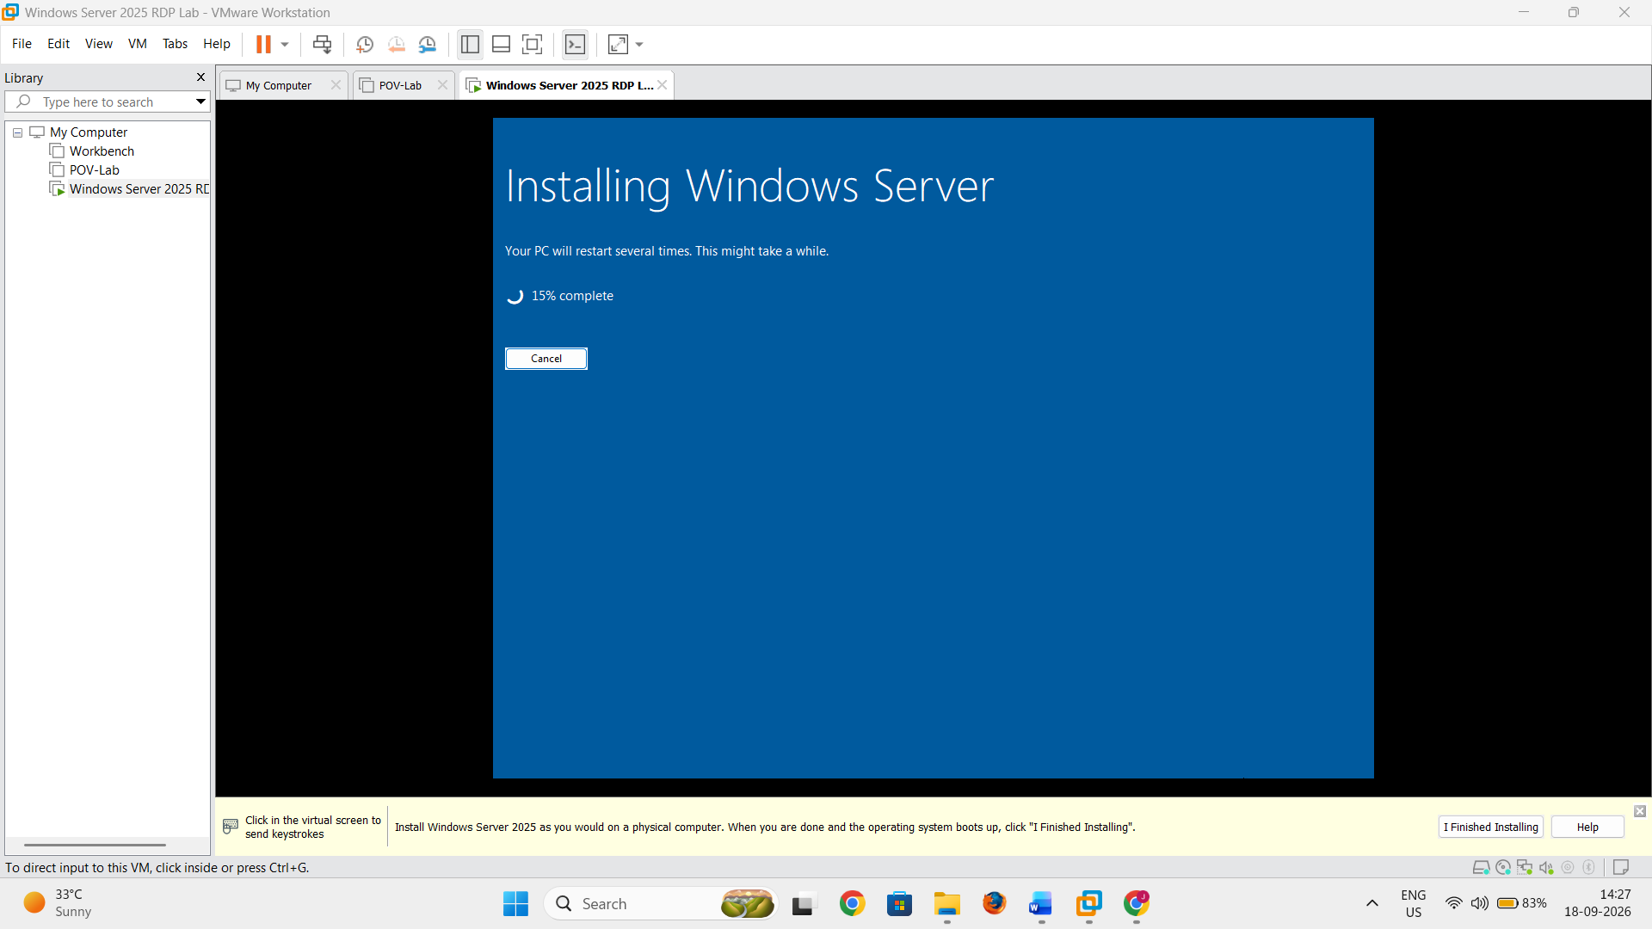
Part E — Configure Windows Server 2025
Step 18: Set the Administrator Password
After the installation is complete, Windows Server will ask you to configure the Administrator account.
- Enter a strong password for the Administrator account.
- Confirm the password.

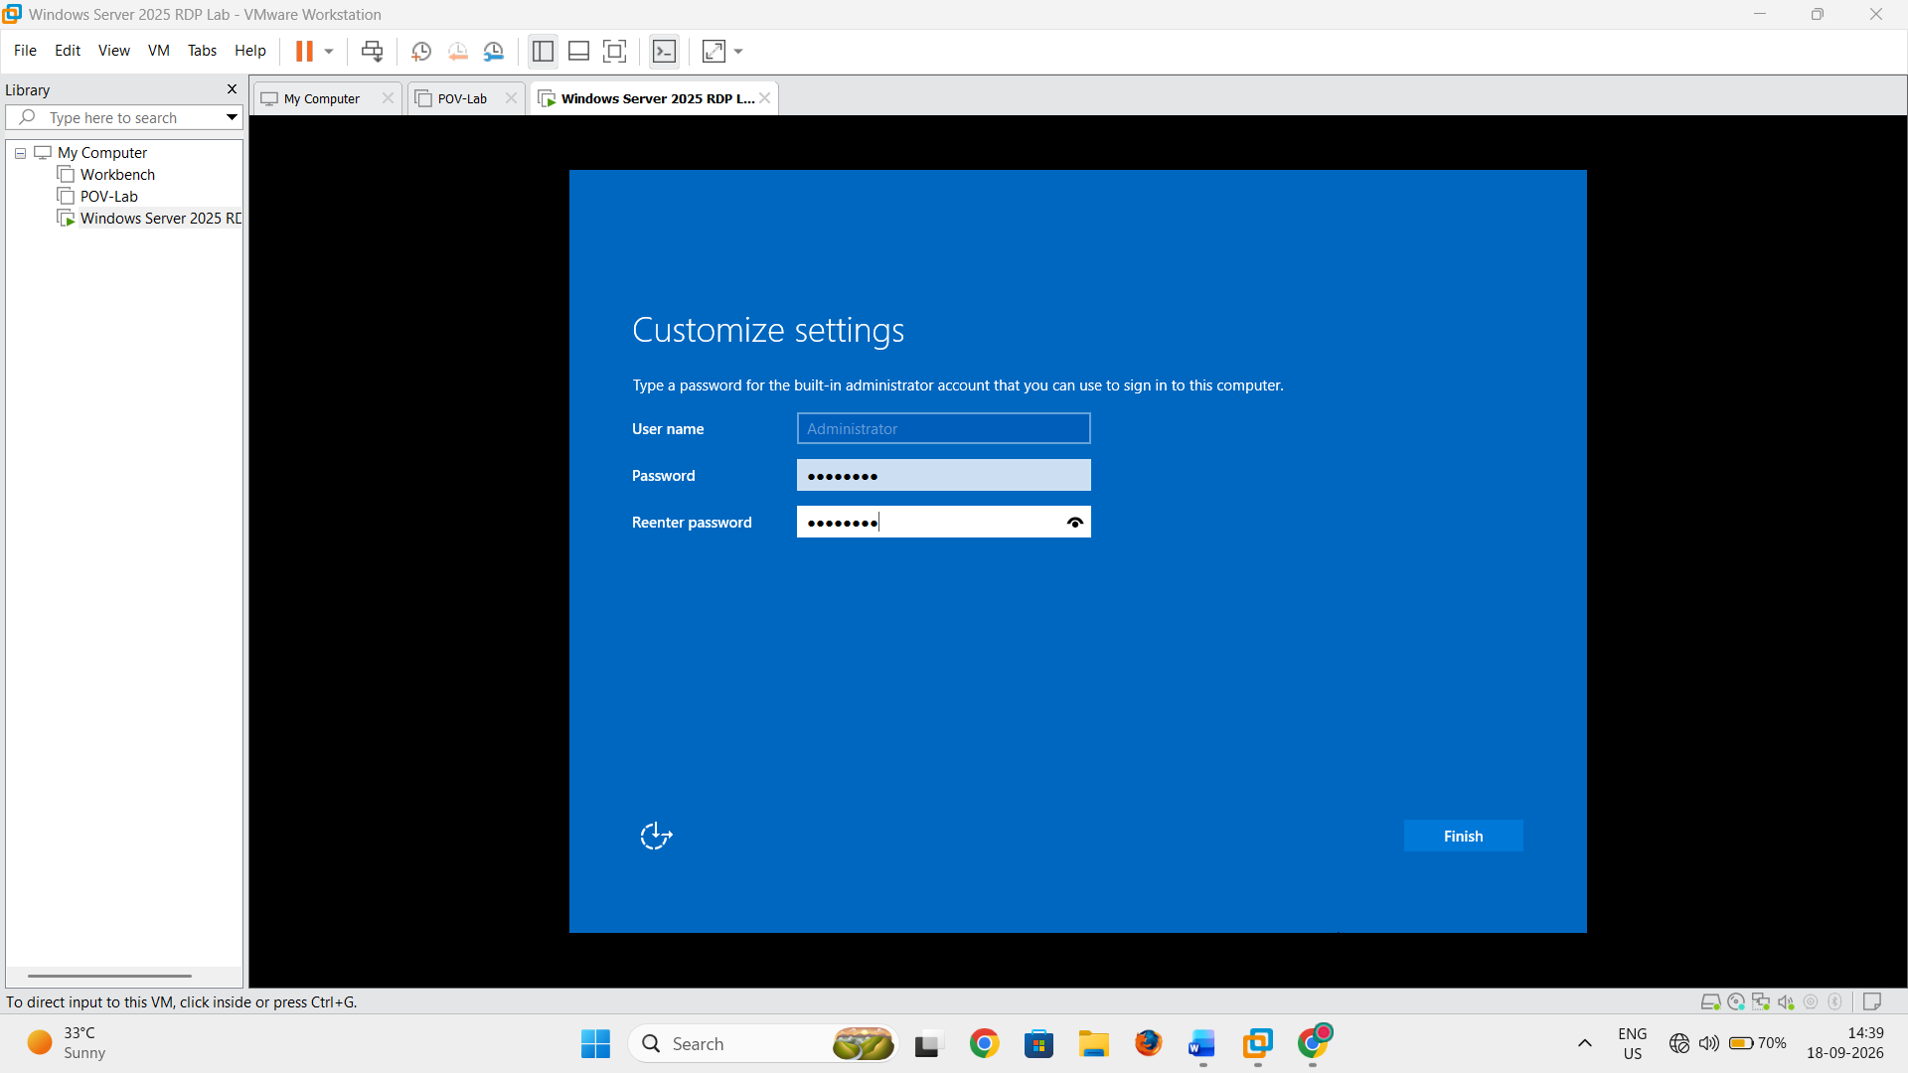
- Log in to Windows Server.

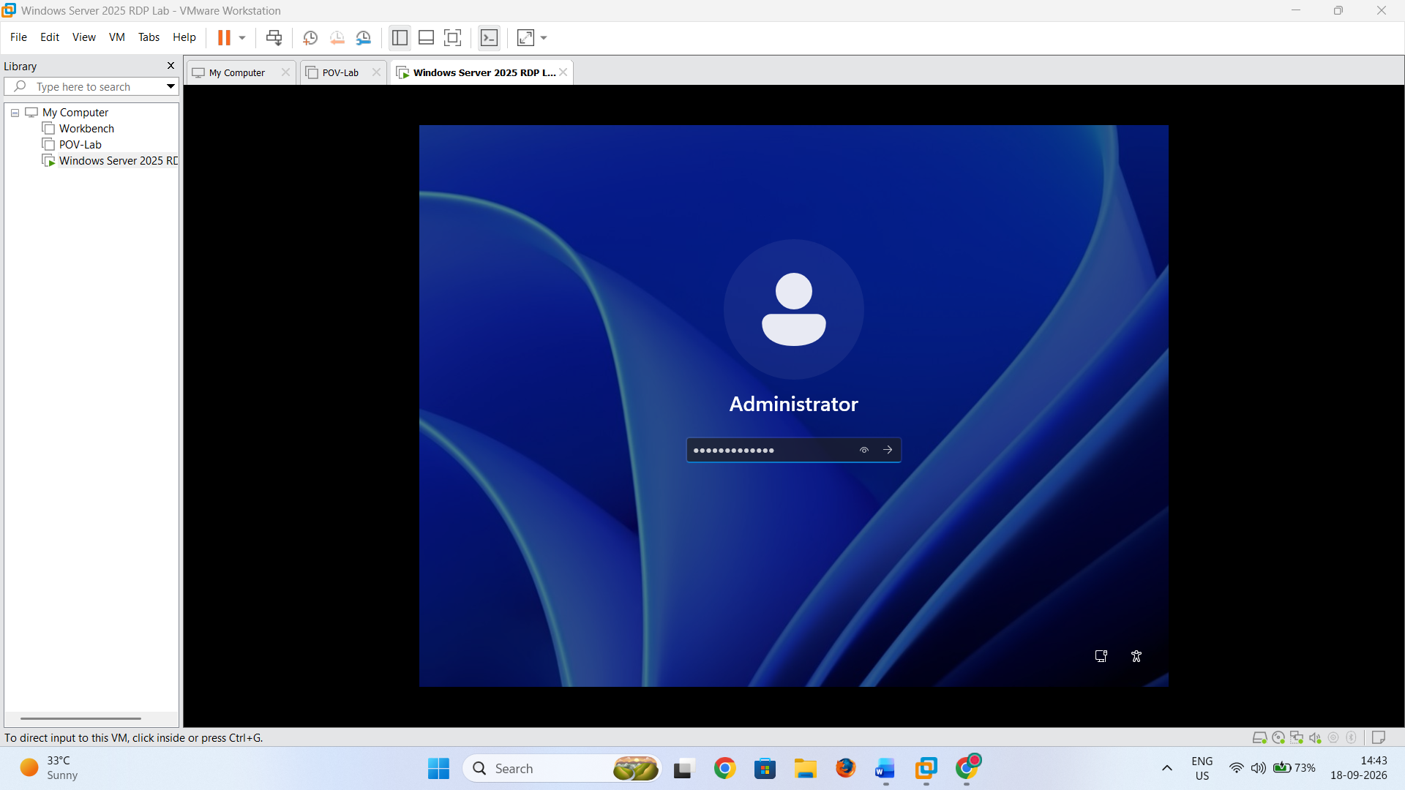
The Windows Server 2025 Desktop Experience desktop should now appear.

Step 19: Check the Server Name
- Open Server Manager.

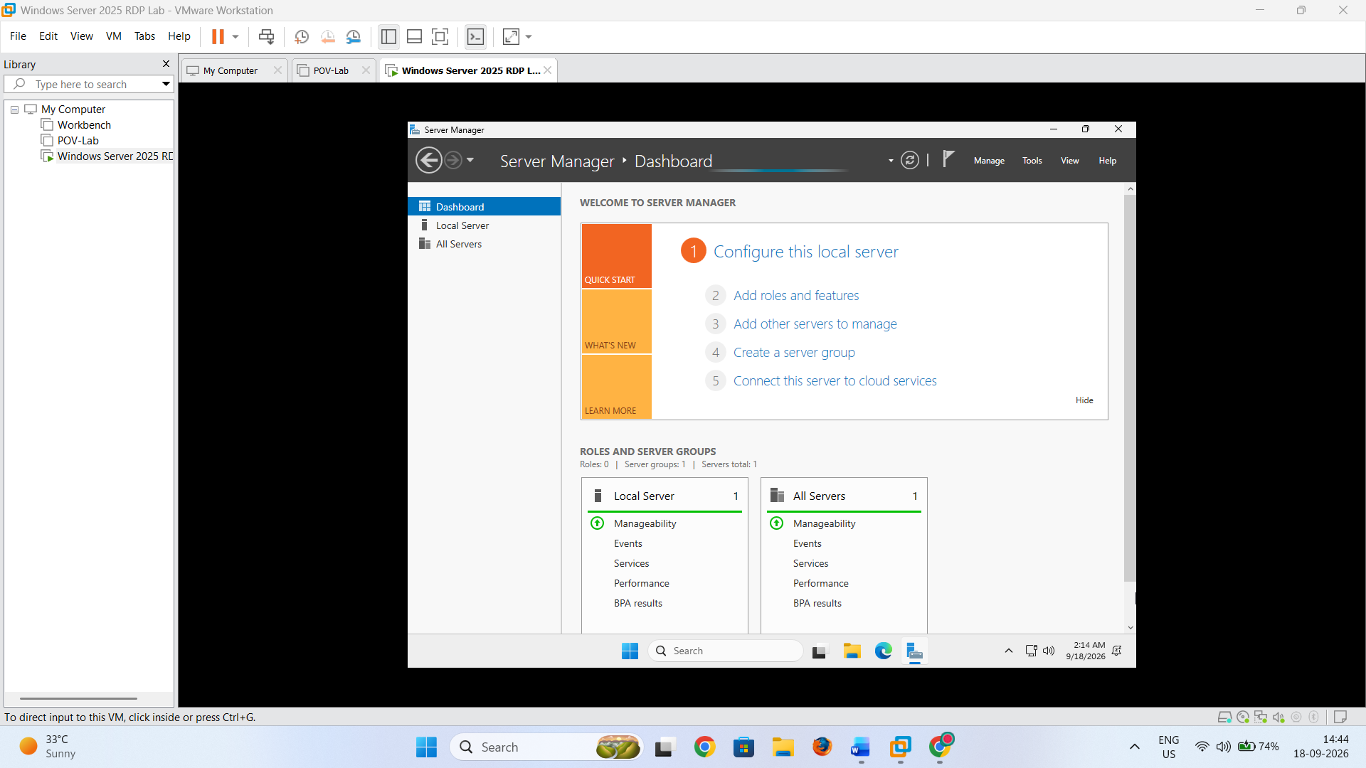
- Select Local Server.
- Check the Computer name.

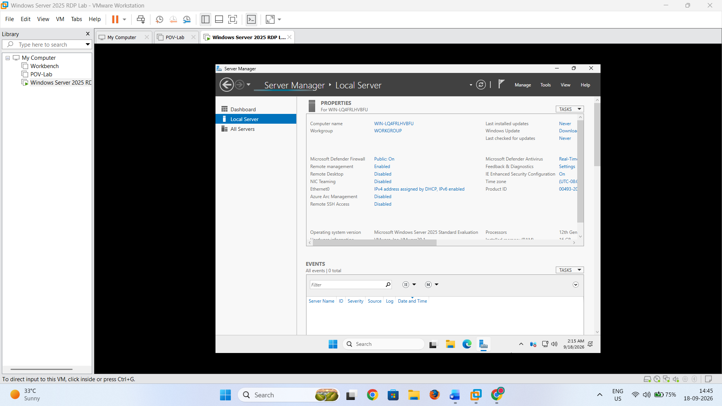
Part F — Check the Server IP Address
Step 20: Open Command Prompt
- Open Command Prompt.
- Type:
ipconfig
- Press Enter.
- Locate the IPv4 Address of the network adapter.

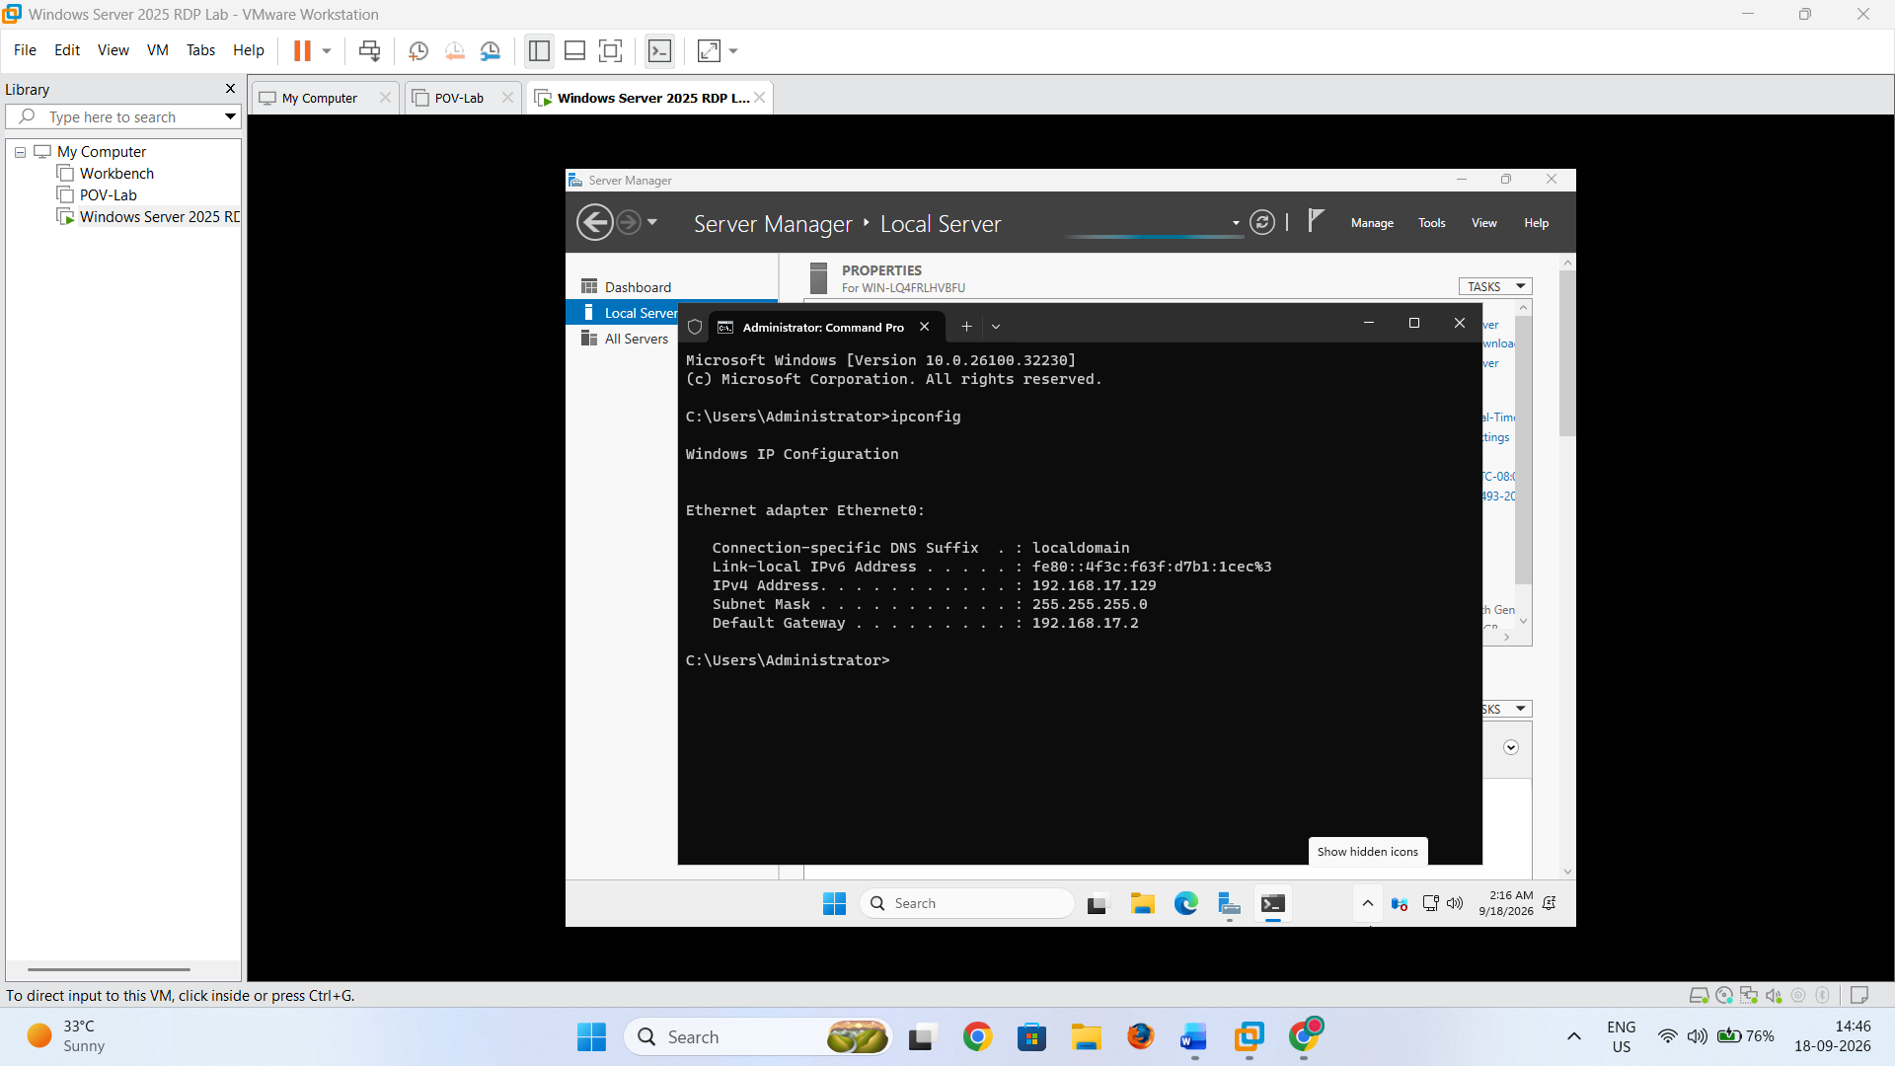Record this IP address because it will be used later when connecting to the server through RDP.

Part G — Enable Remote Desktop
Step 21: Open Remote Desktop Settings
- Open Settings.
- Select System.
- Select Remote Desktop.
- Turn Remote Desktop On.
- Confirm the setting if prompted.

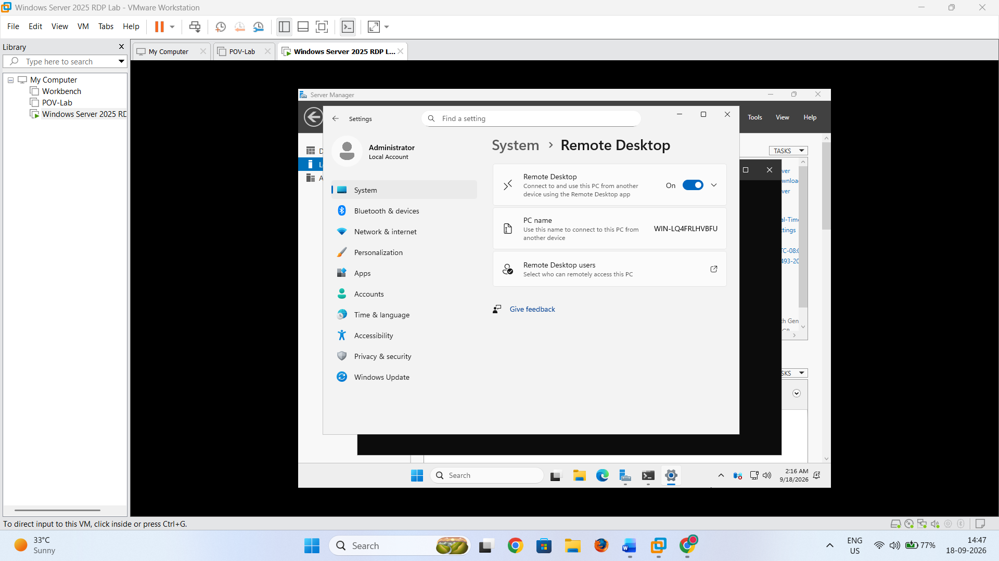
Step 22: Allow Users to Connect
If another Windows user account needs to access the server through RDP:
- Open Remote Desktop settings.
- Select Remote Desktop users.
- Click Add.
- Enter the required username.
- Click OK.
Accounts must have permission to use Remote Desktop before they can establish an RDP session.

Part H — Configure Windows Firewall
Step 23: Check Remote Desktop Firewall Rules
- Open Windows Defender Firewall with Advanced Security.

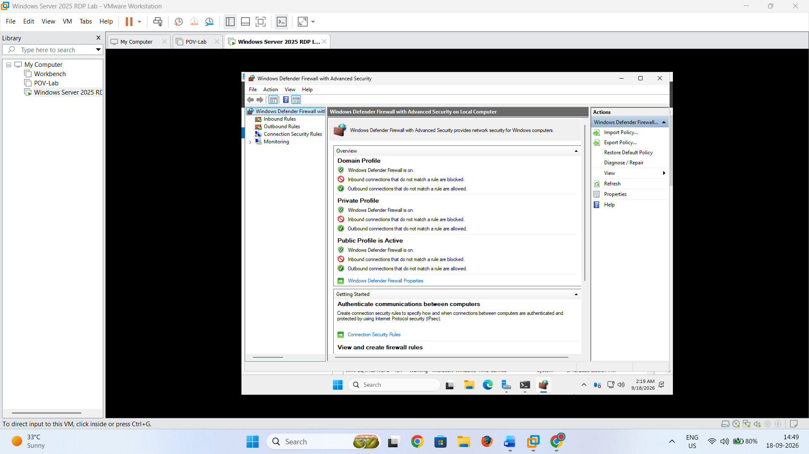
- Select Inbound Rules.
- Locate the Remote Desktop rules.
- Ensure the required Remote Desktop rules are enabled.
RDP normally uses TCP port 3389.
For this VMware laboratory, make sure the Windows Server firewall permits Remote Desktop connections.

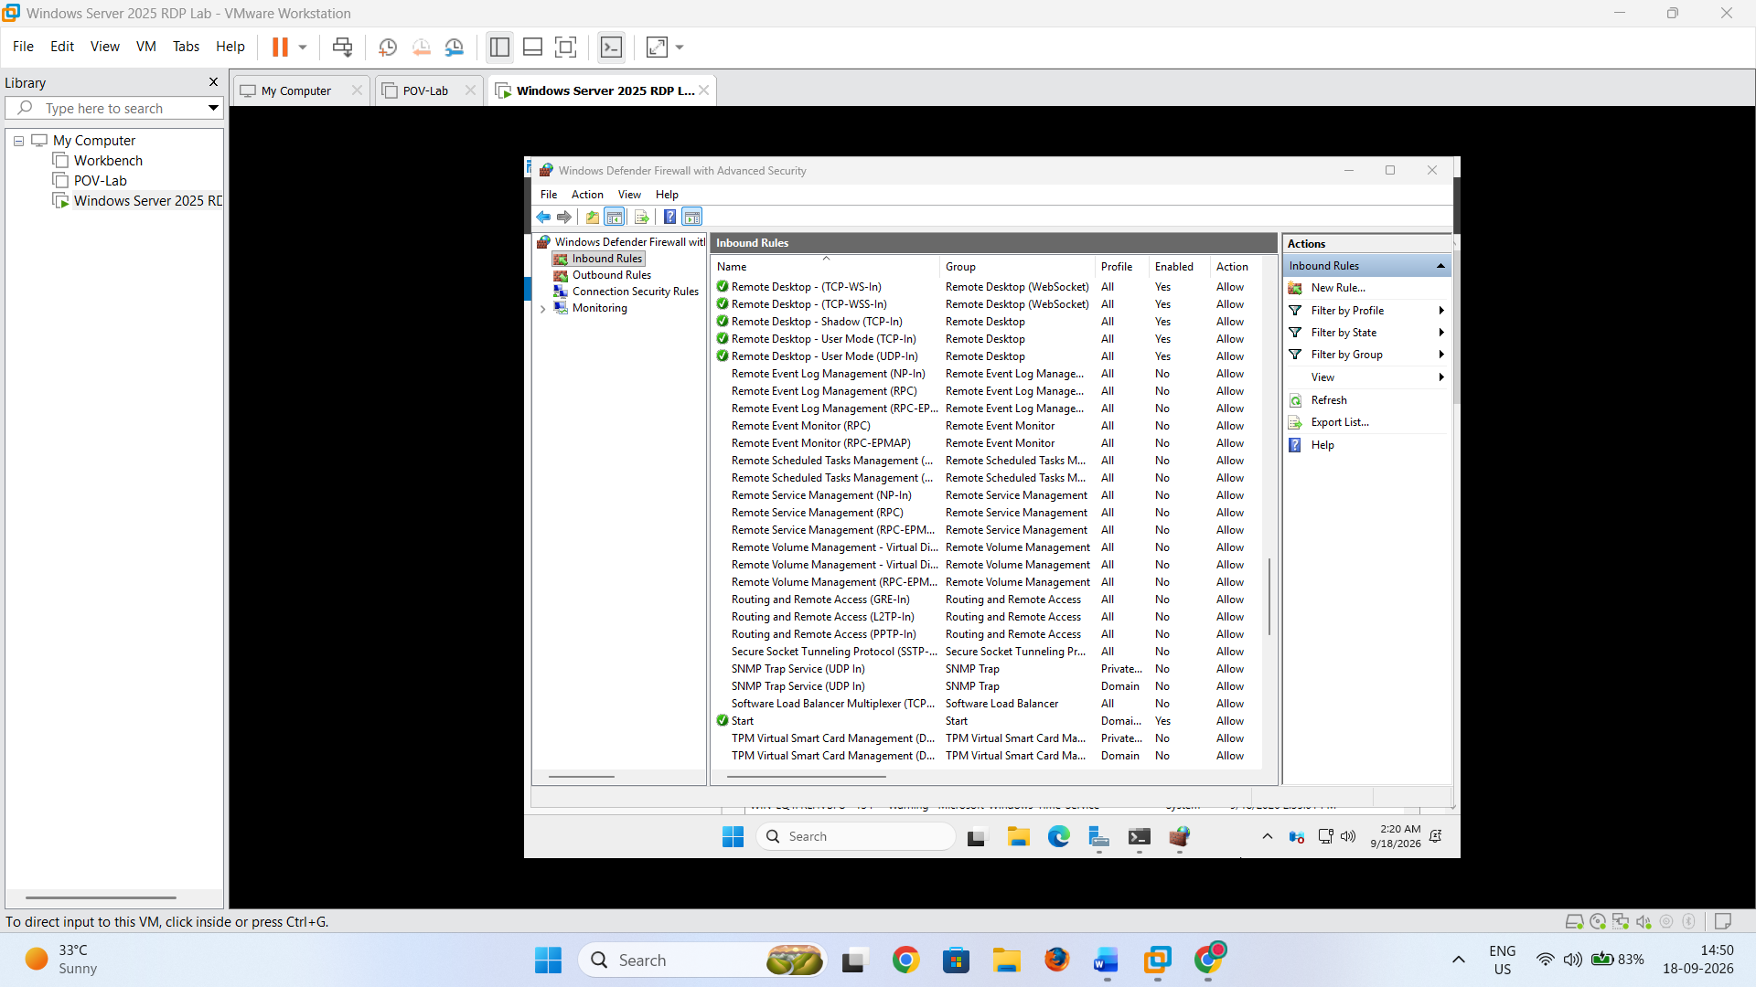

Part I — Connect to Windows Server Using RDP
Step 24: Open Remote Desktop Connection
On the Windows client computer:
- Press:
Windows + R
- Type:
mstsc

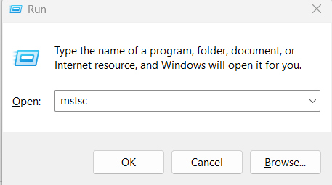
- Press Enter.
The Remote Desktop Connection window will open.

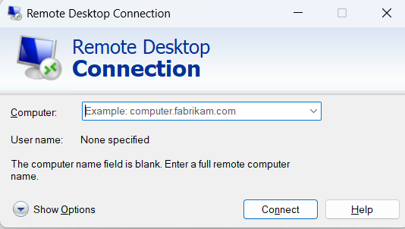
Step 25: Enter the Server IP Address
In the Computer field, enter the IPv4 address obtained earlier.

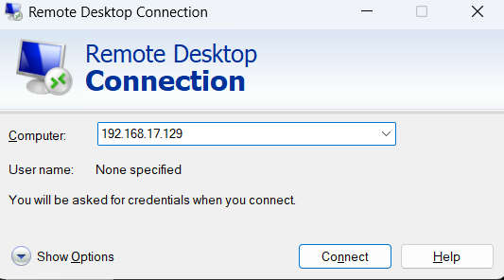
Click Connect.

Step 26: Enter Credentials
Enter the credentials of an account authorized to use Remote Desktop.

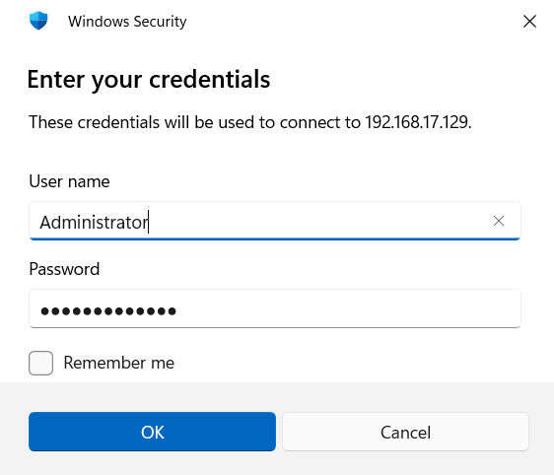
Click OK.

Step 27: Verify the Remote Session
After successful authentication, the Windows Server 2025 desktop should appear in the Remote Desktop window.
To verify that you are connected to the Windows Server virtual machine:
- Open Command Prompt.
- Type:
hostname
- Press Enter.
- Verify that the displayed hostname corresponds to your Windows Server virtual machine.

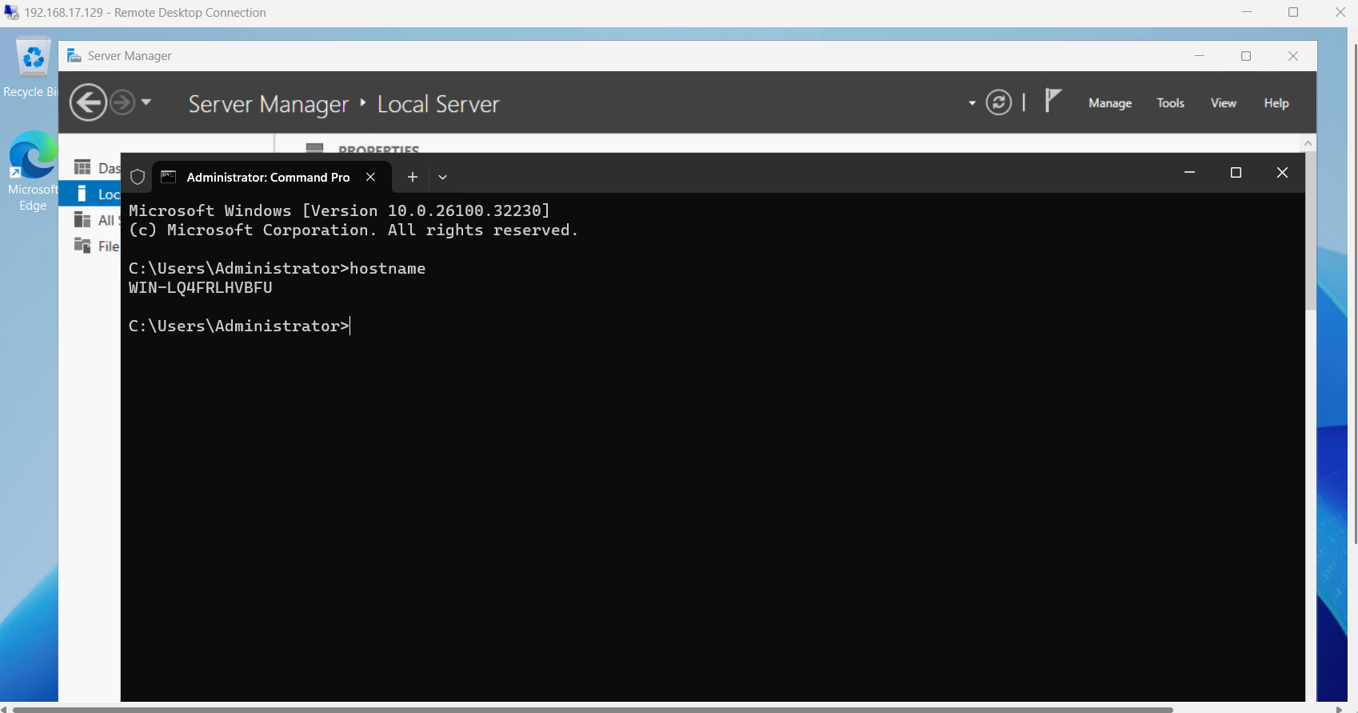
Result
Windows Server 2025 Evaluation Edition was successfully downloaded from the Microsoft Evaluation Center, installed in VMware Workstation Pro using the ISO image, and configured with Remote Desktop. A client computer successfully connected to the Windows Server 2025 virtual machine using RDP.
Precautions
- Download the Windows Server ISO from the official Microsoft Evaluation Center.
- Select Desktop Experience during installation for this practical.
- Allocate sufficient RAM, CPU, and disk space to the VMware virtual machine.
- Make sure the VMware network adapter is enabled.
- Record the server's IPv4 address using ipconfig.
- Allow Remote Desktop through the Windows Firewall.
- Use a strong password for accounts that have Remote Desktop access.
- Enable RDP only on a trusted lab/network environment. Microsoft recommends using Remote Desktop on trusted networks and protecting accounts with strong, unique passwords.
- The evaluation edition is time-limited to 180 days.

